EXPERIMENT 10

Aim:
To design and compare FDMA, TDMA, and CDMA using simple diagrams in Figma.
Procedure:
- Open Figma and create a new design file.
- Create three sections for FDMA, TDMA, and CDMA
- Draw colored blocks to represent different users in FDMA.
- Draw time slots to represent different users in TDMA.
- Draw different colored waveforms to represent users in CDMA.
- Add labels and short descriptions to explain each technique
- Arrange the three diagrams clearly for comparison.
OUTPUT:
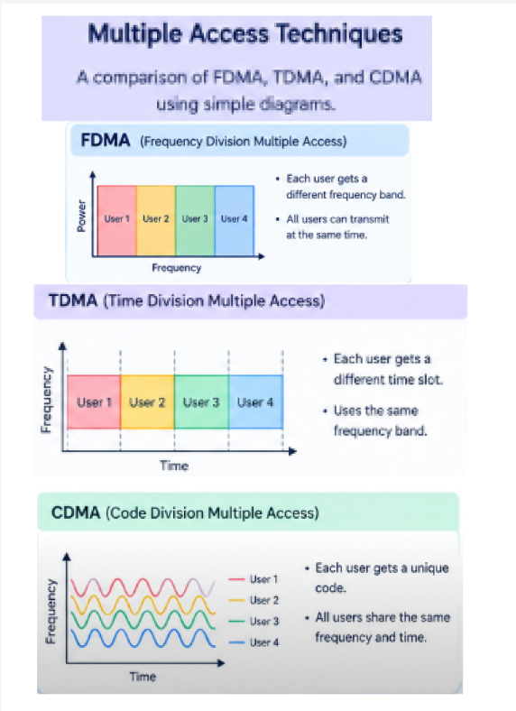

FIGMALINK:
https://www.figma.com/design/ED1qcVpNfWi2Zuft4amJyZ/Untitled?node-id=60-9&t=zih8IyL283jodQsH-0
RESULT: The FDMA, TDMA, and CDMA techniques were successfully designed and compared using simple diagrams in Figma.

